**62 MAX/62 MAX +**

**Infrared Thermometer**

Detailed Picture Explanations

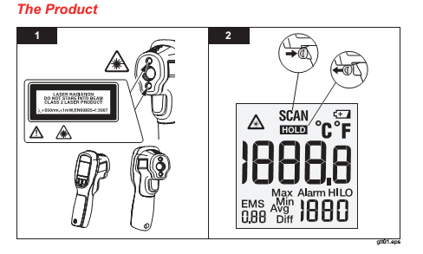

**1**. Laser exit diagram

**2**. While the trigger is pulled you will see “SCAN” on the LCD. After you release the trigger you will see “HOLD” on the LCD. Hold refers to the last temperature taken.

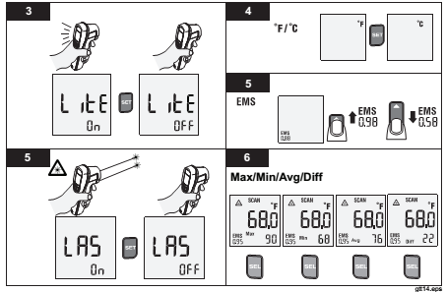

**3**. “LiTE” refers to the backlight being on or off while the trigger is pulled. To access this setting pull the trigger to activate the unit, press “SEL” 4 times, press “SET” for on or off.

**4**. “F” Fahrenheit or “C” Celsius. To access this setting pull the trigger to activate the unit, press “SEL” 9 times, press “SET” to toggle between temperature units.

**5**. “EMS” refers to emissivity. To access this setting pull the trigger to activate the unit, press the “SEL” 8 times, use the up/down key to adjust the value.

**5**. “LAS” refers to the laser activation while the trigger is pulled. To access this setting pull the trigger to activate the unit, press “SEL” 5 times, press “SET” to toggle laser activation.

**6.** “Max/Min/Avg/Diff” refers to Maximum, Minimum, Average and Differential measurement settings. To access these settings pull the trigger to active the unit, press “SEL” 1 time for Avg, 2 times for Diff and 3 times for Max, press “SET” to activate that function.

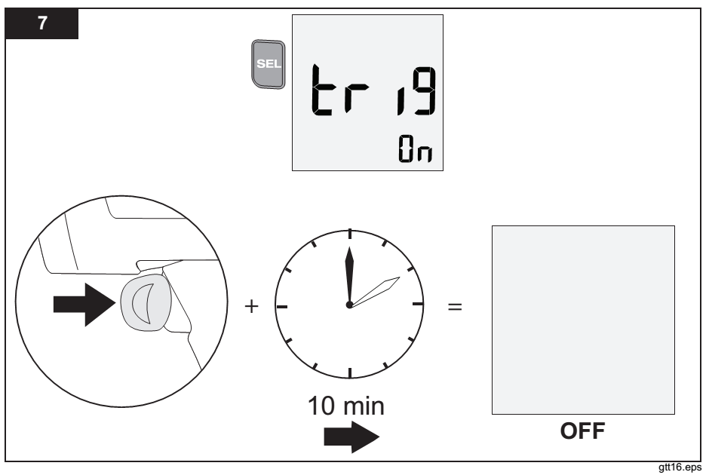

**7.** “tri9” refers to trigger. This function while on means that if the trigger pulled for a total of 10 minutes the unit will shut off. This function is to prevent battery drain from unintended trigger pulls.

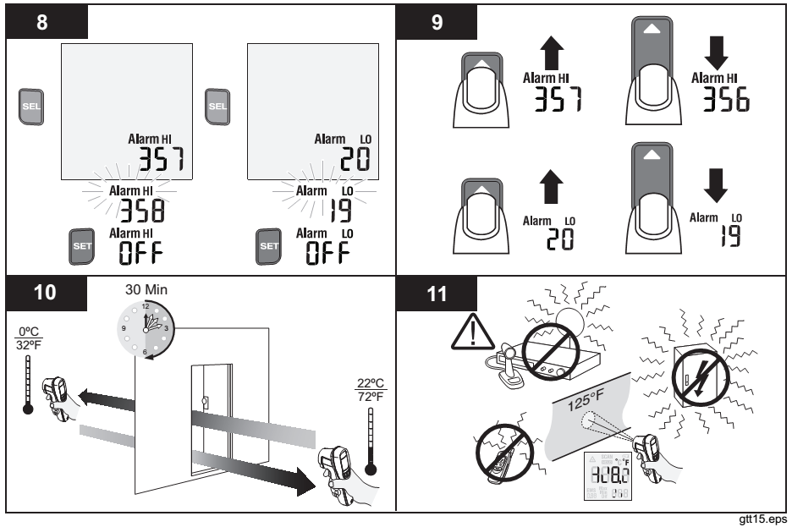

**8. “**Alarm HI” & “Alarm LO”. To access these settings pull the trigger to active the unit, press “SEL” 6 times (7 times Alarm LO) for the “Alarm HI”, press set to toggle the function.

**9.** Once the “Alarm HI” & “Alarm LO” are activated you can set the alarm limits for each by using the up and down arrow button. If these limits are reached while scanning you will see a blinking “Alarm HI” or “Alarm LO” on screen.

**10.** A condition known as thermo shock can occur when taking the instrument from one ambient temperature (32o) to another radically different ambient temperature (72o). The unit will require 30 minutes to acclimate to the new ambient temperature.

**11.** Do not use the instrument while near sources of radio transmission or magnetic fields.

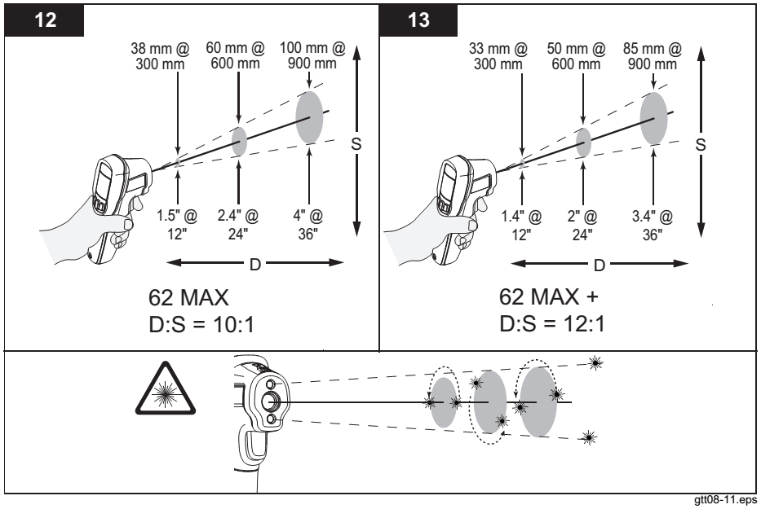

**12. & 13.** D:S stands for Distance to Spot Size ratio. At a given distance you will measure a circular spot size. The temperatures within this spot are averaged for a single reading.

*Example, the 62 MAX + has a D:S of 12:1. This means at 24 inches you will measure a 2 inch spot size.*

The lower diagram refers to 62 MAX + using a dual laser system. The lasers points will position themselves depending on the distance to your target, visually indication the spot size edges.

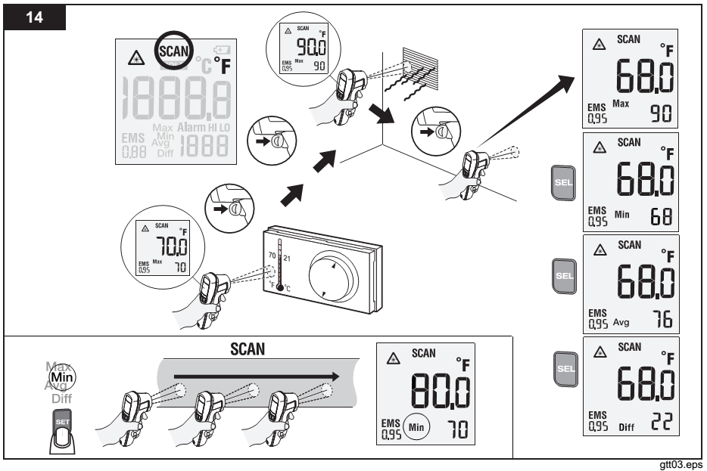

**14.** The “SEL” button can be used to access the MAX, MIN, AVG and DIFF functions. Once selected, press the “SET” button to activate that function. Pull the trigger again to use selected function.

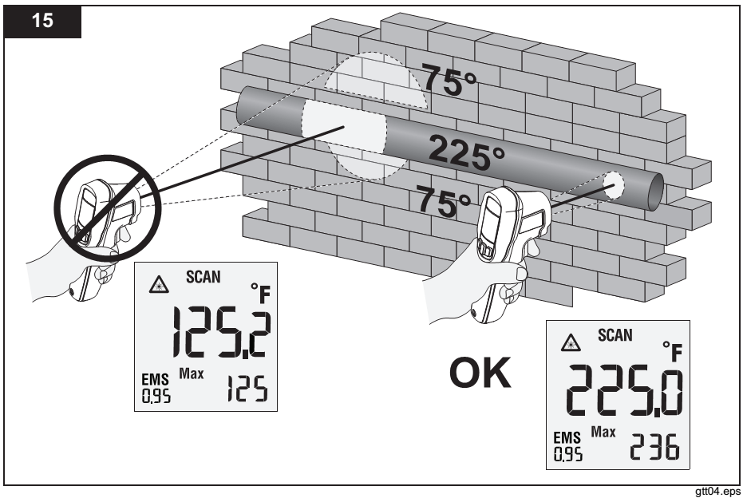

**15.** Make sure to take your distance to spot size into account while scanning surfaces with varying temperature. *62 MAX = 10:1, 62 MAX + = 12:1*

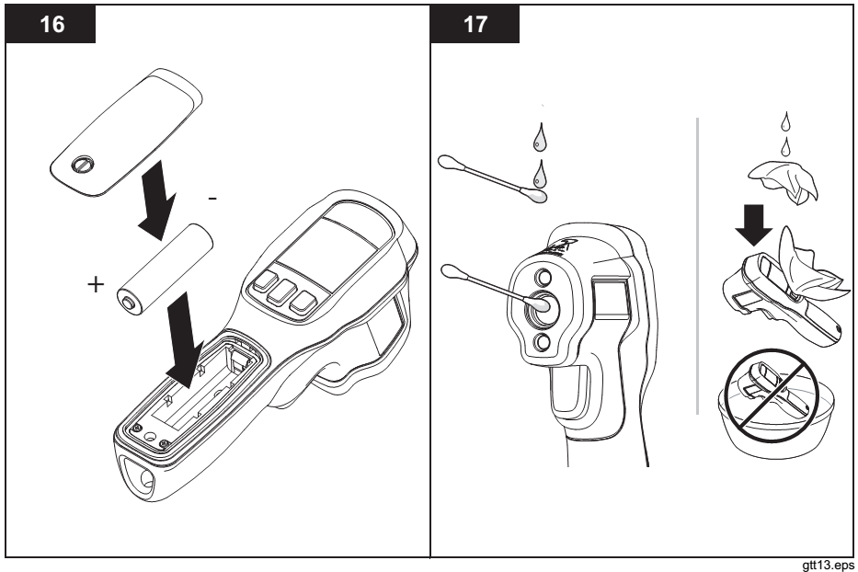

**16.** Battery compartment and battery alignment. (1 AA alkaline battery)

**17.** Clean the lens with light soapy water and a cotton swab. Clean the body of the unit with a damp cloth. Do not immerse the instrument in any solutions.